WireGuard Lab (Project 3) Report

Name: Karim Haidari

Course: CYB-3533 System Administration

Project: WireGuard Lab (Project 3)

**Overview**

The goal of this lab was to deploy a WireGuard VPN server on a DigitalOcean droplet using Docker and Docker Compose, connect a mobile phone as a WireGuard peer, verify that the VPN tunnel is working by checking the public IP address, and document the entire process with screenshots and explanations.

Screenshot 1 – DigitalOcean Droplet Overview

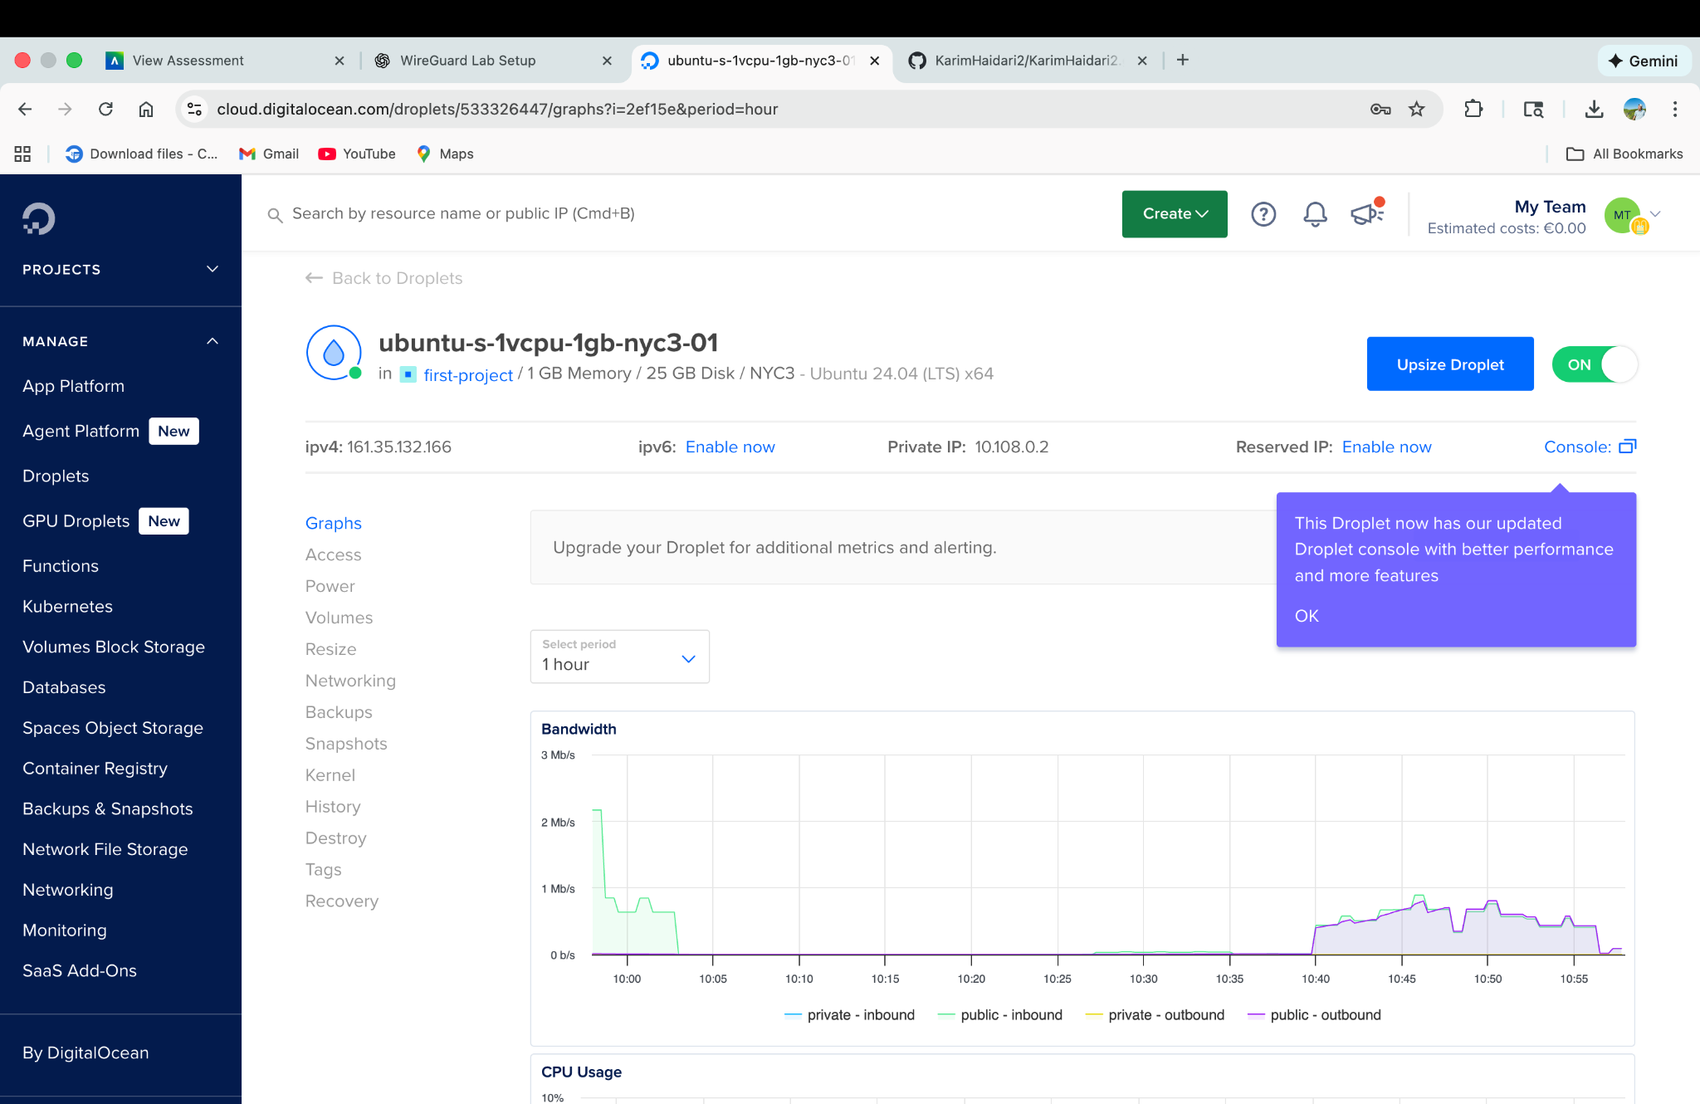

This screenshot shows the DigitalOcean control panel for my droplet named 'ubuntu-s-1vcpu-1gb-nyc3-01'. The droplet is running Ubuntu 24.04 LTS with 1 GB of memory and 25 GB of disk in the NYC3 region. The public IPv4 address 161.35.132.166 is highlighted and was later used as the WireGuard server's endpoint. The droplet status is 'Active', confirming that the virtual machine is online and ready for SSH connections.

## Screenshot 2 – Installing Docker and Docker Compose on the Droplet

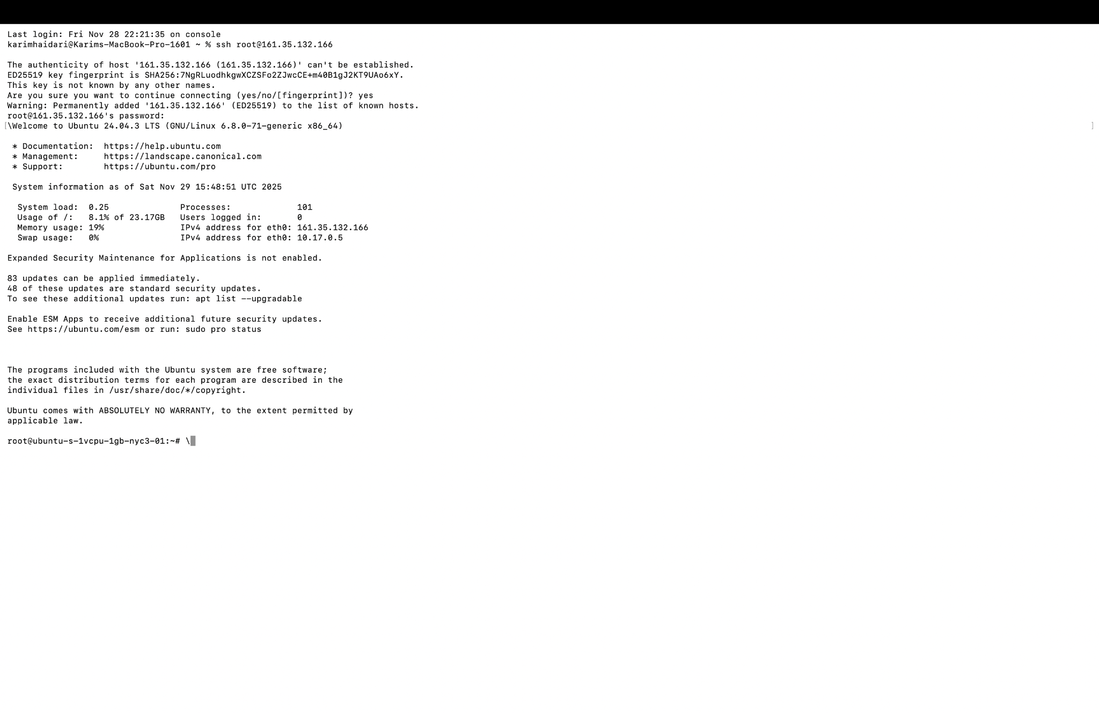

In this screenshot, I installed Docker Engine and Docker Compose on the Ubuntu droplet. The output shows packages such as 'docker-ce', 'docker-ce-cli', 'containerd.io', and 'docker-compose-plugin' being unpacked and configured. Near the bottom, I verified the installation by running 'docker --version' and 'docker compose version', which report Docker version 29.0.1 and Docker Compose v2.4.3. This confirms that the container runtime required for the WireGuard container is working correctly.

## Screenshot 3 – Editing docker-compose.yml

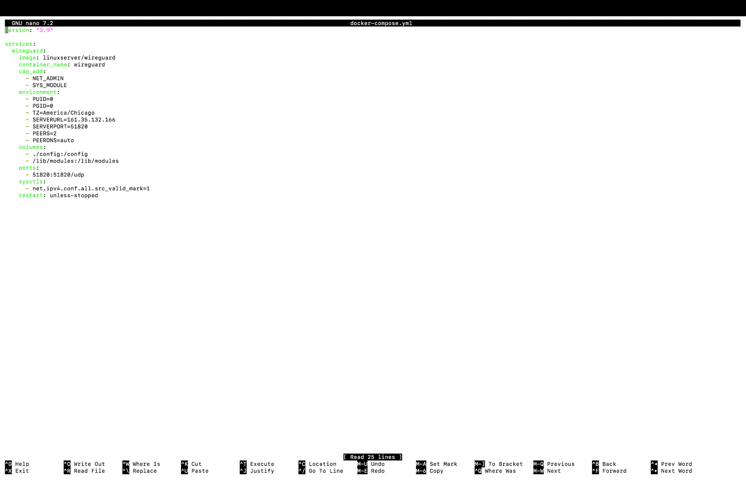

This screenshot shows the 'docker-compose.yml' file open in the nano text editor. In this file I defined a single service named 'wireguard' using the 'linuxserver/wireguard' image. I configured important environment variables such as PUID, PGID, the time zone (America/Chicago), the server's public IP (161.35.132.166), the WireGuard port 51820, and the number of peers. I also mapped a local './config' directory into '/config' inside the container and exposed UDP port 51820. Finally, I set the container to restart unless stopped so that the VPN service comes back automatically after a reboot.

## Screenshot 4 – Starting WireGuard with Docker Compose

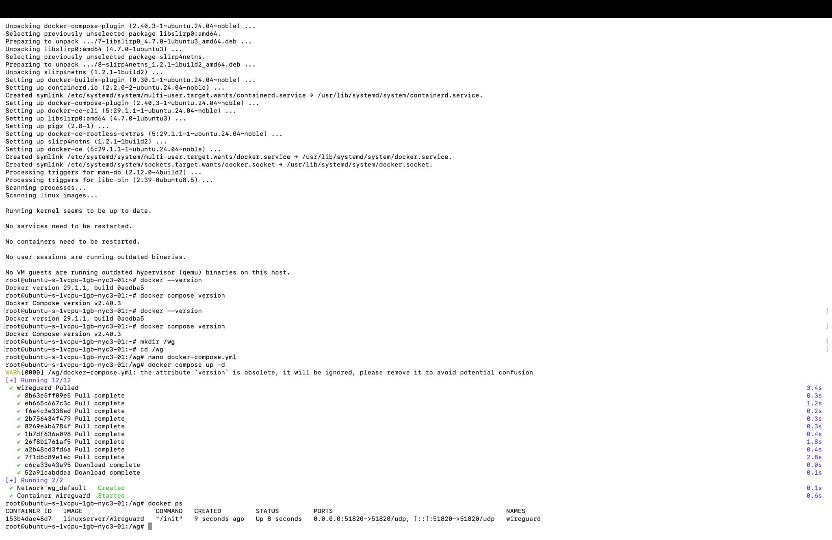

Here I ran 'docker compose up -d' in the directory containing 'docker-compose.yml'. The output shows Docker pulling the WireGuard image layers (multiple 'Pull complete' messages) and then creating the 'wireguard' container and the default 'wg_default' network. The line 'Container wireguard Started' confirms that the WireGuard server is now running in the background. At the bottom, 'docker ps' shows the container listening on UDP port 51820 on 0.0.0.0, which makes the VPN accessible from the internet.

## Screenshot 5 – Generated WireGuard Peer Configuration Files

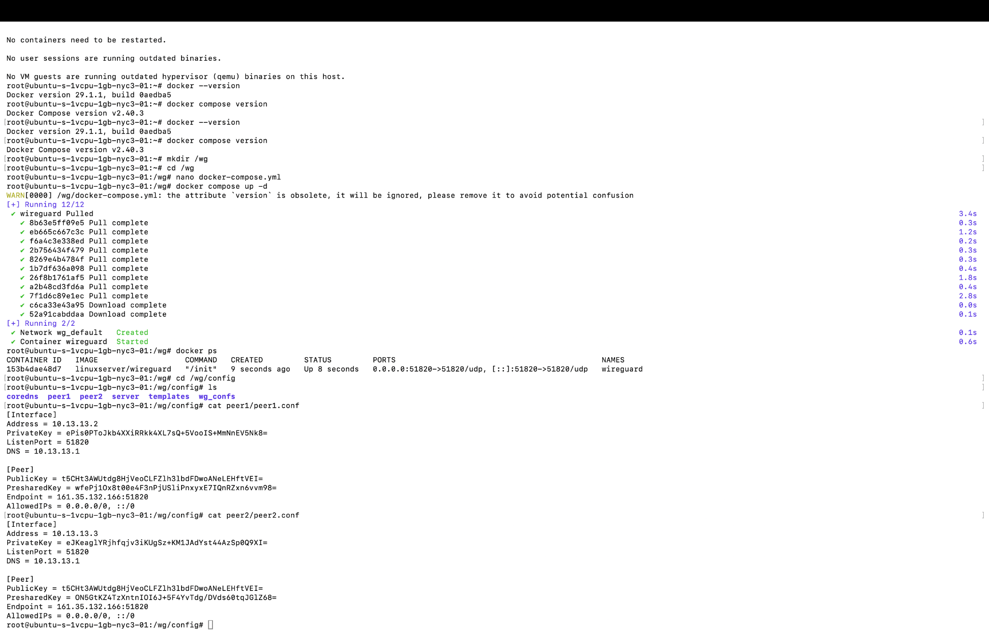

After the container started, the LinuxServer WireGuard image automatically generated configuration files for each peer. In this screenshot, I changed into the '/wg/config' directory inside the container and viewed 'peer1/peer1.conf' and 'peer2/peer2.conf'. Each config contains an [Interface] section with the peer's private key and internal VPN IP address, and a [Peer] section that references the server's public key, endpoint (161.35.132.166:51820), and allowed IP ranges. I used 'cat peer1/peer1.conf' to display the peer1 configuration that I later imported into the WireGuard mobile app.

## Screenshot 6 – Copying peer1.conf with scp

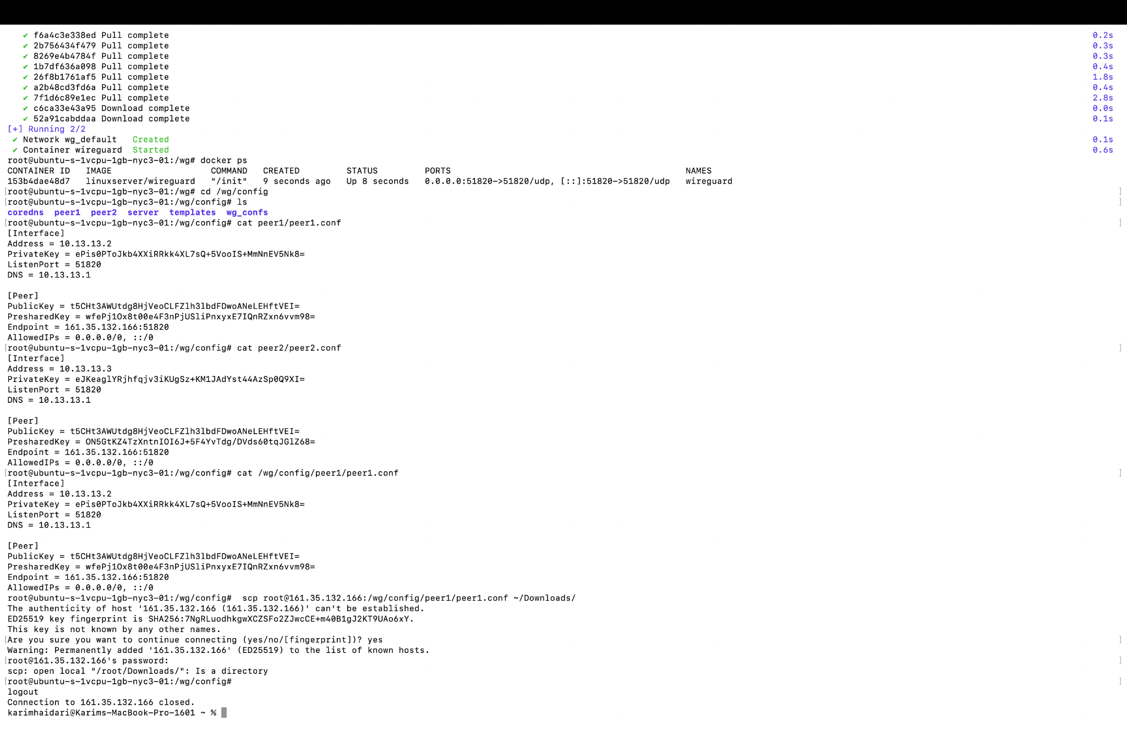

This screenshot shows how I copied the 'peer1.conf' file from the droplet to my local MacBook. From the '/wg/config' directory, I used the command:  
  
scp root@161.35.132.166:/wg/config/peer1/peer1.conf ~/Downloads/  
  
The first attempt failed because '~root/Downloads' did not exist, so I reconnected via SSH from my MacBook user account and ran the 'scp' command again, specifying my local Downloads folder. Once the file was downloaded, I could either transfer it to my phone or use it to generate a QR code.

## Screenshot 7 – Generating a WireGuard QR Code for Peer 1

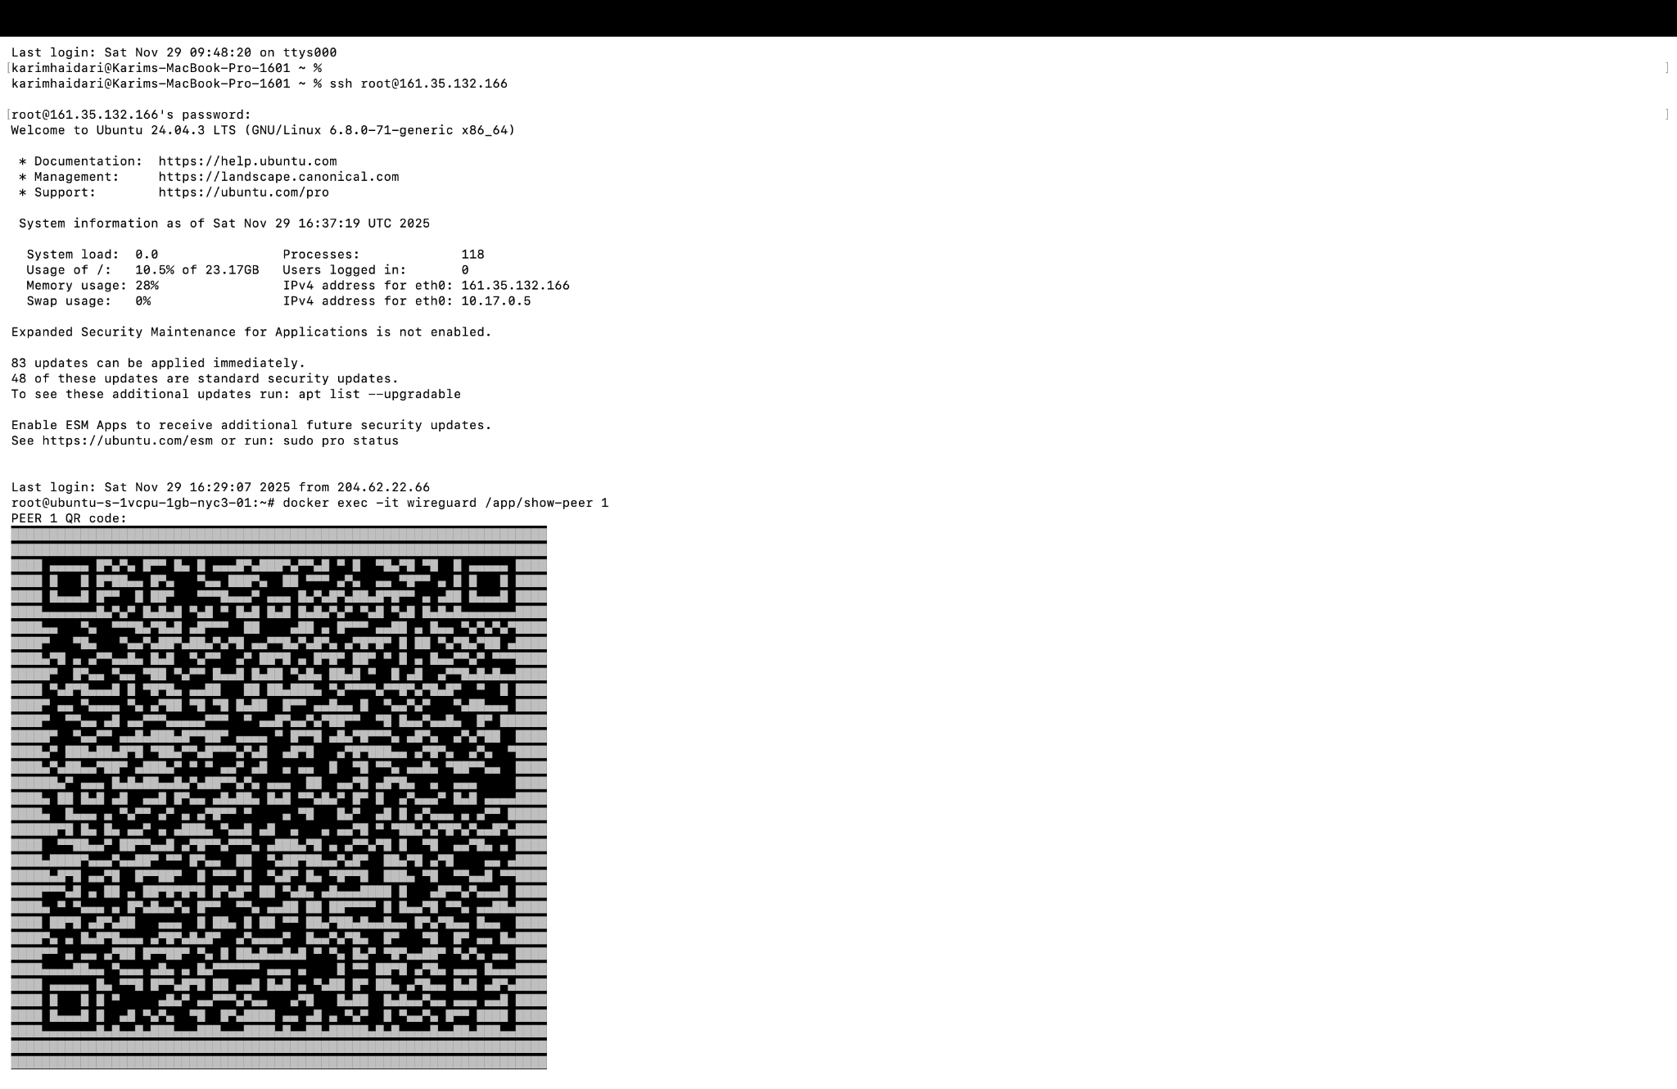

To make it easy to import the configuration into the mobile app, I generated a QR code directly on the server. Using the LinuxServer utility script, I ran:  
  
docker exec -it wireguard /app/show-peer 1  
  
The command outputs a large QR code in the terminal labeled 'PEER 1 QR code'. I pointed the WireGuard iOS app at this QR code using the phone's camera to import all the settings for the tunnel named 'Project 3' automatically, without manually typing keys or addresses.

## Screenshot 8 – WireGuard Mobile App with Active Tunnel

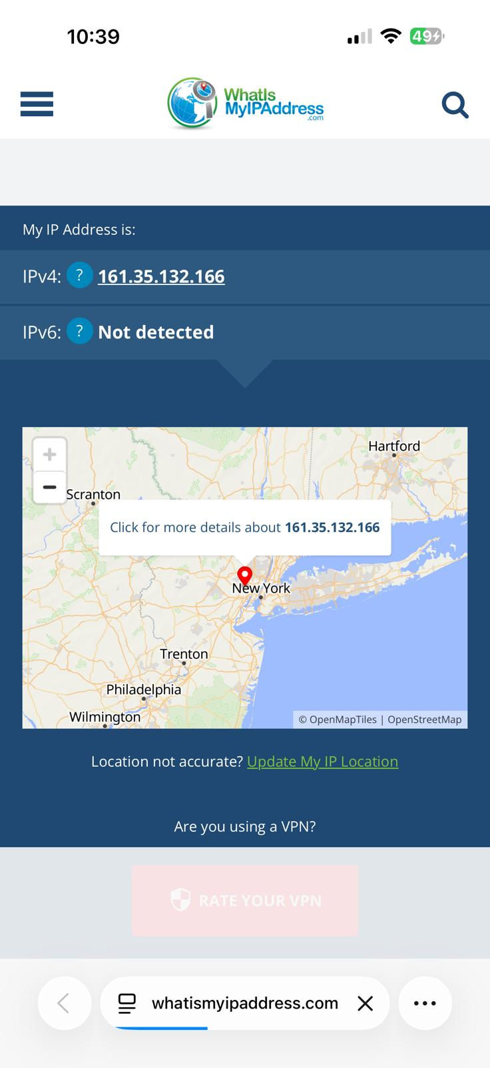

This screenshot is from my iPhone, showing the WireGuard app with a single tunnel named 'Project 3'. The toggle switch is in the green 'on' position, meaning the VPN tunnel is active and the phone's traffic is being routed through the WireGuard server running on my DigitalOcean droplet.

## Screenshot 9 – Verifying VPN Using WhatIsMyIPAddress.com

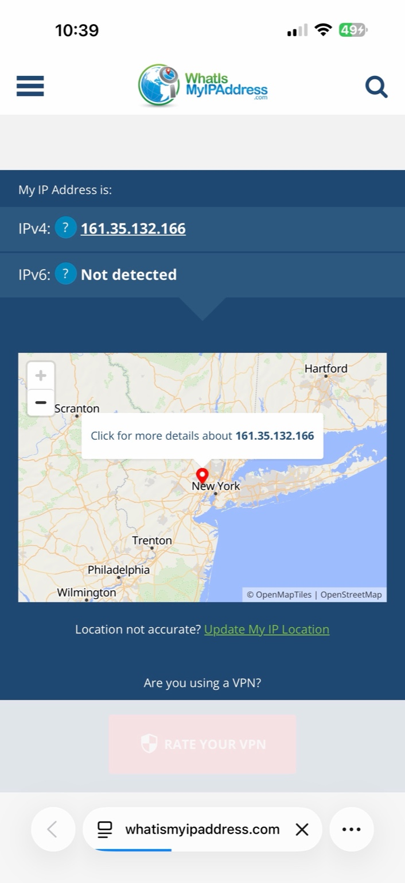

To verify that my phone was actually using the VPN, I visited whatismyipaddress.com while the WireGuard tunnel was enabled. The website reported my IPv4 address as 161.35.132.166, which matches the public IP of my DigitalOcean droplet instead of my home or cellular IP. This confirms that all traffic from the phone is being tunneled through the WireGuard server as required by the lab instructions.

This additional screenshot of the WireGuard app again shows the 'Project 3' tunnel enabled. Capturing this screen provides clear evidence that the configuration imported from the QR code is active and that the mobile device is connected to the VPN tunnel.

## Screenshot 11 – Inspecting WireGuard Config Directories

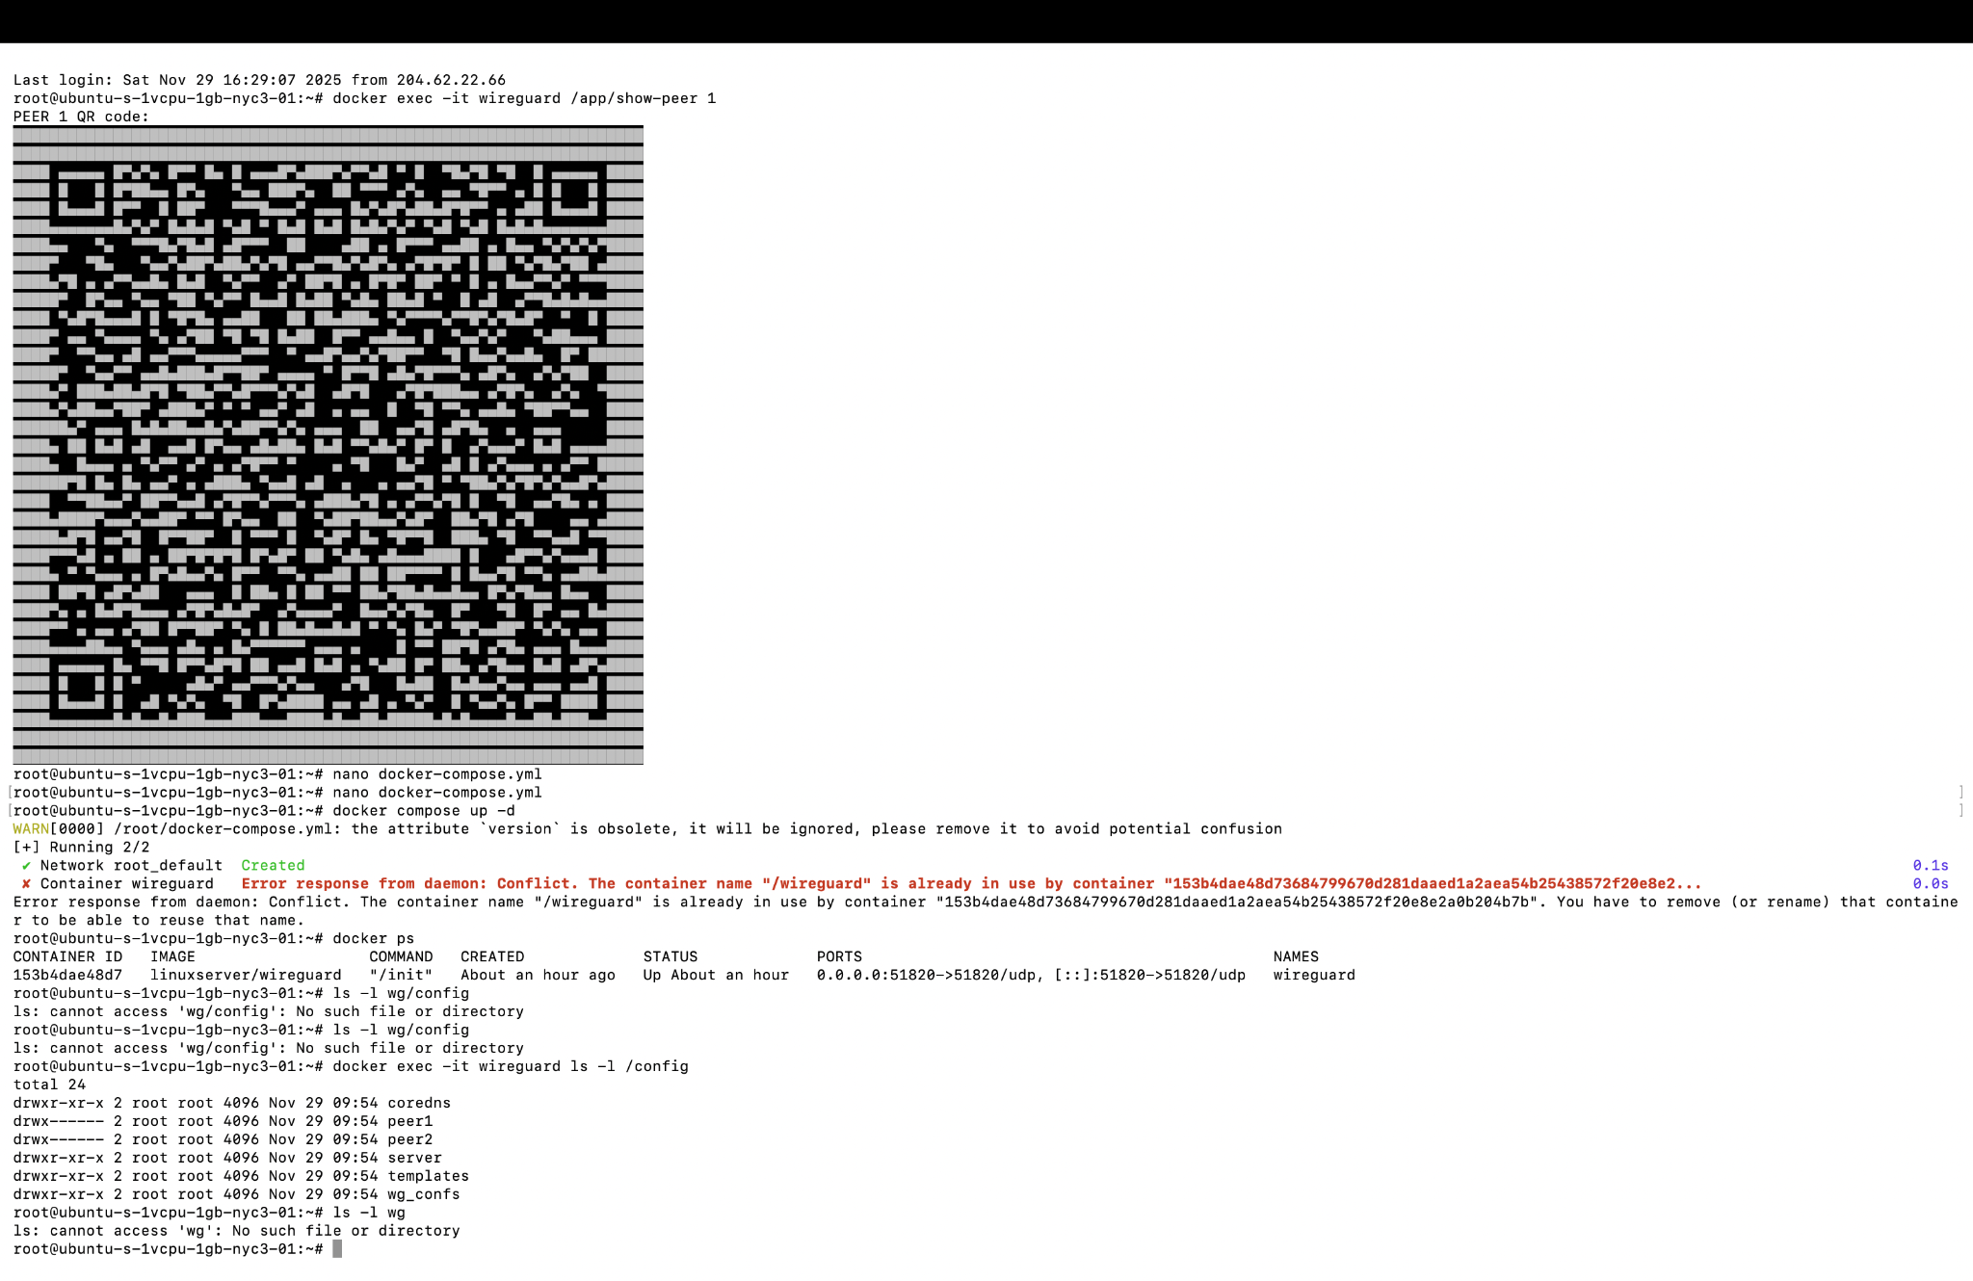

Here I ran several commands to inspect the WireGuard configuration directories. After seeing an error that '/wg-config' did not exist, I listed the root directory and then the '/config' directory, which showed subdirectories like 'server', 'wg_conf', and 'wg_configs'. This helped confirm where the LinuxServer image stored the configuration files and ensured I knew which paths to use when generating QR codes and copying peer configuration files.

# WireGuard Log File

The lab also produced a WireGuard log file on the server. The log captures events such as interface startup, peer handshakes, and data transfer. A copy of the log file named 'wireguard-log-2025-11-29T164125Z.txt' is included with this report for reference.

# Summary and Reflection

In this project I successfully deployed a WireGuard VPN server inside a Docker container on a DigitalOcean droplet, created peer configurations, and connected my iPhone as a VPN client. I verified the connection by confirming that my public IP address changed to the droplet's IP while the tunnel was active. The main challenges were understanding where the LinuxServer image stored the configuration files, fixing the initial 'scp' path mistake when copying peer1.conf, and making sure the correct endpoint IP and port were used in the configuration. By troubleshooting these issues and carefully following each step, I was able to complete the lab successfully and document the full process.